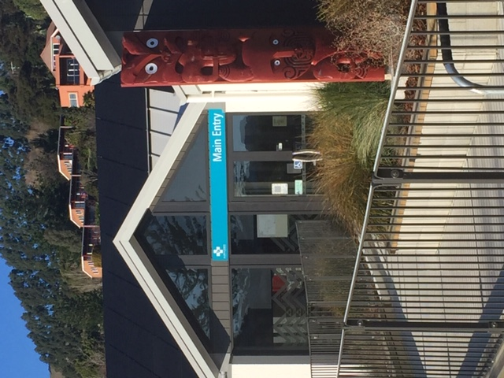

Akaroa Health Te Hauora o Rākaihautū

Māori Health Plan

 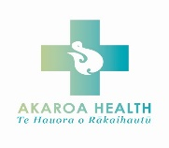

# Introduction

This Māori Health Plan for Akaroa Health Te Hauora o Rākaihautū sets out the organisation approach and objectives for improving Māori Health outcomes. This plan has been developed in partnership with Ōnuku rūnanga.

Ōnuku marae, based 5 km from Akaroa, is home to the hapū (sub-tribe) of Ngāi Tārewa and Ngāti Īrakehu. It has been the setting for some of the most significant and historic events seeded in the founding of our nation including the signing of the Tiriti o Waitangi (Treaty of Waitangi) by our Tīpuna (ancestors).

Te Hauora o Rākaihautū provides integrated health services to the Akaroa and Bays communities. This Māori Health Plan is developed to work across the whole organisation and with all services. These include

* primary care services
* community-based services
* acute afterhours services
* inpatient urgent care and rehabilitative services
* aged residential care and respite services

Te Hauora o Rākaihautū is committed to the Te Tiriti o Waitangi and to having a meaningful partnership with iwi.  Central to this is a shared understanding that health is a taonga (treasure). We value people, respect diversity, and are responsive to reducing disparities in health.

Te Hauora o Rākaihautū’s vision is a ‘The best health and wellbeing for the Akaroa and Bays community’. In the context of the vision “healthy” incorporates a holistic health approach aligned to the Māori health and wellness model Te Whare Tapa Whā. Te Whare Tapa Whā sets out four dimensions or pillars of health; Taha Tinana (physical health), Taha HInengaro (mental and emotional wellbeing), Taha Whānau (social wellbeing) and Taha Wairua (spiritual wellbeing). Te Hauora o Rākaihautū vision of health includes these four dimensions.

The Te Hauora o Rākaihautū Māori Health plan is centered on achieving Māori Health equity and Māori participation in services. We as an organisation are committed to meeting the health needs and aspirations of Māori in the Akaroa and Bays community.

This plan is a living document that is regularly monitored by Te Hauora o Rākaihautū staff and Board. The document will be reviewed annually with a report to the Board on the achievements against the objectives.

# Overview

As reported in the 2014 to 2018 CDHB Māori Health Policy Statistics, Māori people are not getting the equal health to which they are entitled under Te Tiriti O Waitangi.

Compared with non-Māori, Māori people are:

* Over five times more likely to die from diabetes
* Twice as likely to die in accident
* 2.4 times more likely to die from lung cancer
* 1.3 times more likely to die from heart disease or stroke
* 2.13 times more likely to live in a household with no access to a vehicle.
* Earn $4000 per year less on average
* 40% less likely to own their home
* 2.5 times more likely to live in overcrowded conditions
* 2.8 times more likely to smoke
* 40% less likely to access cervical cancer screening and 4.2 times more likely to die of cervical cancer

In Canterbury specifically, there are some differences from the national statistics for Māori. We have higher hospitalisation rates for respiratory, cardiovascular, mental health and pregnancy related problems but lower rates for injury, poisoning and digestive disorders. Māori in Canterbury generally have lower levels of deprivation than Māori in the rest of New Zealand but remain relatively deprived when compared with the non-Māori population of Canterbury.

They are more likely to live in cheaper accommodation and more likely to be living in overcrowded conditions.

# Our Māori Health Model - Te Whare Tapa Whā

# Te Whare Tapa Whā — THE YOUTH DEVELOPMENT CHAMPIONS PROJECT

**Whenua - Land, roots**

The foundation of the other 4 dimensions, your health and wellbeing is directly linked to the health of the land and natural environment. Connection to the land and to nature has been shown to improve mental and physical wellbeing.

**Te taha wairua - spiritual wellbeing**

There is no right or wrong way to think of wairua, it is who and what you are. Spiritual wellbeing can be expressed through beliefs, values, traditions and practices that support self-awareness and identity.

**Te taha hinengaro – mental and emotional wellbeing**

This pillar represents your mind, heart, thoughts and feelings.

**Te taha tinana - physical wellbeing**

Physical wellbeing helps you to feel mentally well. This pillar is about how your body grows and feels and how you care for it. Physical activity and healthy eating are two key influences on taha tinana.

**Te taha whānau - Family wellbeing**

Whānau is about extended relationships, not just your family but your friends, colleagues and community. Whānau plays a central role in your wellbeing as it is a source of strength, security, support and identity.

# Akaroa Health Snapshot

Our current data shows that at February 2024

150 of our enrolled patients identify as Māori this is 9.6% of our total enrolled population. There is representation across all age brackets with the largest bracket being 45-64 years.

# Our commitment to improving Māori Health

**Ethnicity data collection**

If we don't know who our Māori are, we cannot identify areas of need or measure health outcomes.

We will help by:

* Ensuring we collect data about the ethnic identity of our patients on our enrolment form, including iwi
* Make our practice comfortable to Māori people to express their identity, including provision of bilingual signage and information
* Supporting patients who may be struggling with their identity - patients can change their primary ethnicity at any time
* Supporting patients who identify with more than one culture to record up to three ethnicities

**Enrolment in Primary Care**

Primary healthcare is the best way to ensure longer term better healthcare outcomes and that requires a longer-term relationship.

We will help by:

* Making it easy to get care – have a good range of appointments available and offering the choice of a telephone consult where appropriate
* Keeping our fees low and working with Māori patients to ensure they can afford the fees
* Providing assistance when completing the enrollment form if required

**Lower rates of hospitalisation for Māori**

Māori are more likely to be admitted to hospital as an emergency than non-Māori

We will help by:

* Making it easy to get care, from our range of specialists
* Free appointments for tamariki under the age of 14
* Support and encourage full immunisation
* Making every effort to support Māori to quit smoking
* Supporting Māori with asthma and diabetes to have better control of their illness
* Ensuring that Māori are especially encouraged to have appropriate screening tests
* Ensuring that we exceed our targets for the provision of cardiovascular disease screening

**Improve Cancer Outcomes**

Māori are more likely to develop cancers and more likely to attend the doctor when it is too late.

We will help by:

* Making every effort to support Māori to quit smoking
* Supporting Wahine to access breast and cervical screening
* Making sure that Māori are aware of the earliest signs of cancer, so they can access treatment more quickly

**Improve Mental Health**

Māori are more than three times as likely to be placed under a community treatment order as non-Māori. Earlier treatment can improve outcomes.

We will help by:

* Being a place Māori can trust and where they feel comfortable
* Employ Māori specialist staff
* Offering long appointments at no charge for mental health issues and offering reduced price or free follow-up appointments
* Recognising that Māori may have difficulty explaining mental health issues in ways that we understand

In addition to the above:

All AHL and it’s staff shall:

* Be aware of Māori values, beliefs, protocols and cultural issues.
* Attend training in cultural competency at least every 3 years to enhance understanding and respect for Māori.
* Maintain an understanding of the Treaty of Waitangi
* Every year a community meeting will be held encouraging all community members including Māori to attend meet staff, hear about the previous year, ask questions and to offer ideas and suggestions as to how we can improve healthcare provision for them. This meeting shall be advertised at the facility, on social media and in the local newspaper.
* Actively include Māori in decision making, especially where it relates to Māori health outcomes
* Have accountability for Māori health equity is incorporated into all position descriptions
* Supporting, promoting and encouraging key Māori focused events throughout the organisation with culturally competent communications
* Employ Māori across all positions
* Develop and embed a Maori specific care plan for our inpatients and residents
* Invite and encourage Māori to participate at all levels of the company including our Board and Clinical Governance Group.